SYSTEMS SUMMARY
PIPER TWIN COMANCHE PA-30B SERIAL #30-1386

Normally aspirated – no tip tanks – 160hp per side

Airframe and control surfaces

Sheet-aluminum construction.

Extremities (wingtips, rudder end pieces, etc.) – fiberglass or ABS thermoplastic.

Fuselage – all-metal, semi-monococque construction consisting of bulkheads, strings, stiffeners, and longitudinal beams to which the outer skin is riveted.

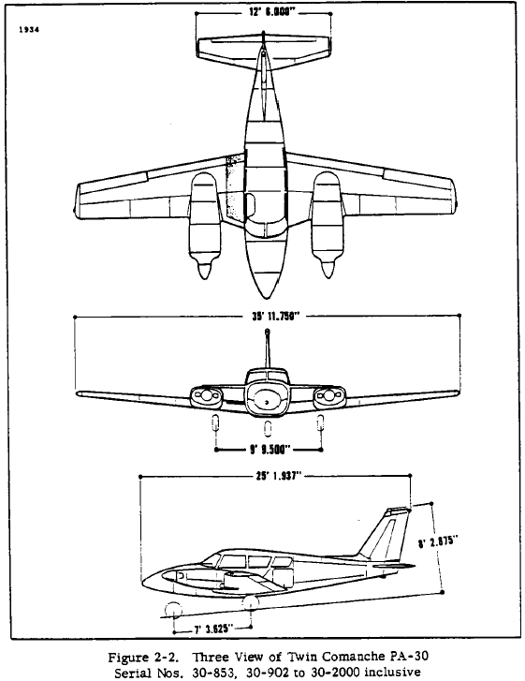

Length: 25.2 feet.
Height: 8.2 feet.
Wing span: 36 feet.

Flaps are actuated electrically by a flap transmission.

Wing flap limitations:
- Zero to 15 degrees (Takeoff)
- Zero to 27 degrees (Landing)

An aileron-rudder interconnect system is employed to reduce control forces necessary for coordinated turns.

Aileron travel is 19 degrees deflection up (+/- 1 degree) and 15 degrees deflection (+/- 1 degree) down.

The horizontal stabilizer functions as a stabilator with anti-servo tab also serving as a trim tab, adjustable from the cockpit. The stabilator’s surface travel is + 5 ½ degrees (+/- 1 degree) and – 15 ½ degrees (+/- 1 degree.) The stabilator trim tab’s travel is 9 degrees positive and negative, +/- 1 degree.

The rudder’s travel is 27 degrees left, 27 degrees right, +/- 1 degree, resulting in a total arc of 54 degrees.

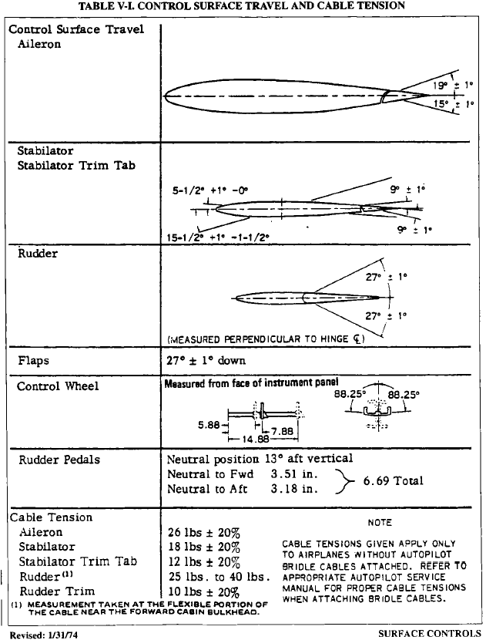

Starting with an external power source is accomplished by attaching the external power cable to the auxiliary power receptacle located on the left (pilot) side of the fuselage forward of the windshield.

The procedure for starting with an external power source is as follows:

- Master switch: check OFF.
- All electrical equipment: check OFF.
- Alternate Battery Terminals: CONNECT.
- External Power Cable: INSERT IN FUSELAGE.
- Magnetos: ON.
- Initiate appropriate starting procedure.
- Throttles: lowest possible RPM.
- External Power Cable: DISCONNECT FROM FUSELAGE.
- Throttle: above 1200 RPM.
- Master Switch: ON.
- Ammeter: CHECK for normal charging.
- Do not attempt flight if battery is not charging properly.

Airfoil

All-metal stressed skin, full-cantilever design.

Wing section is a NACA 64₂ A215 Laminar Flow airfoil with maximum thickness about 40% aft of the leading edge.

Aspect ratio is 7.3. Wing area is 178 sq. ft. Wing loading is 20.2 lb./sq. ft. Power loading is 11.3 lb./bhp. Dihedral is 5 degrees with zero twist.

Main spar is extruded beam with high-strength butt fittings at the center of the fuselage making in effect a continuous main spar.

All-metal empennage group is a full-cantilever design. Stabilator and vertical fin have two-channel main spars running full length. The stabilator is attached to the fuselage by a torque tube supported by bearing blocks.

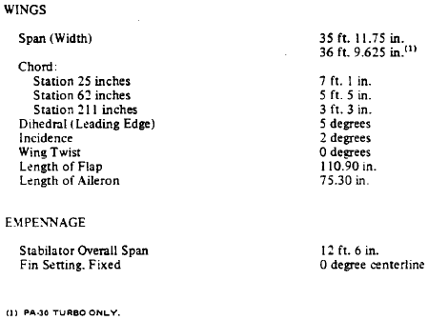

Engine, ignition, lubrication and propeller

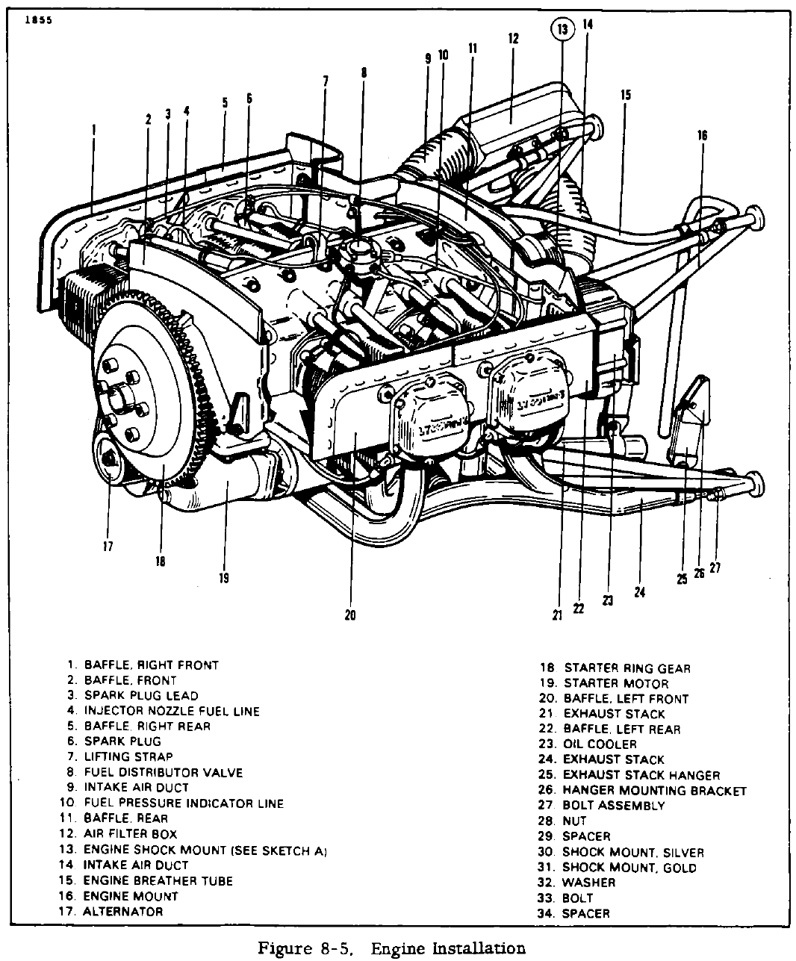

The PA-30B is equipped with two Lycoming IO-320-B1A series engines with a compression ratio of 8.5:1 rated at 160bhp each at 2700RPM. The IO-320-B series engines are four cylinder, direct drive, wet sump, horizontally opposed, air cooled, clockwise rotation, fuel-injected, and have 319.8 cubic inches of displacement. Runs on minimum 91/96 octane aviation-grade fuel. Accessories furnished with the engines are geared starters, 50-ampere, 12-volt generators, dual vacuum pumps, direct-drive fuel pumps, dry automotive-type induction air filters, and dual magnetos. An external oil cooler is mounted on the left rear of each engine baffle. The pilot may manually control engine ram-air cooling by operation of cowl flaps via mechanical linkage.

Maximum CHT is 500 degrees Fahrenheit. Maximum oil temperature is 245 degrees Fahrenheit. Minimum oil pressure is 25 psi.

Oil temperature gauge limits:
- 120-245 degrees Fahrenheit (green arc)
- 60-120 degrees Fahrenheit (yellow arc)

Oil pressure gauge limits:
- 60-90 psi (green arc)
- 25-60 and 90-100 psi (yellow arc)
- 25 psi – minimum (red line)
- 100 psi – maximum (red line)
Fuel flow:
- Zero to 16.0 gph (green arc)
- 16.0 gph (red line)

Cylinder head temperature:
- 200-500 degrees Fahrenheit (green arc)
- 200 degrees Fahrenheit – minimum temperature (red line)
- 500 degrees Fahrenheit – maximum temperature (red line)

Instrument vacuum:
- 4.8 to 5.1 in. Hg. (green arc)
- 4.8 – minimum suction (red line)
- 5.1 – maximum suction (red line)

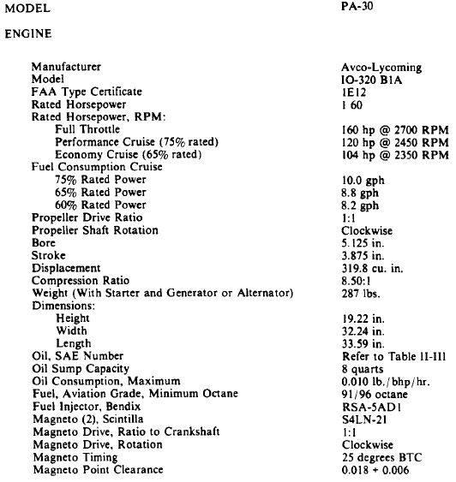

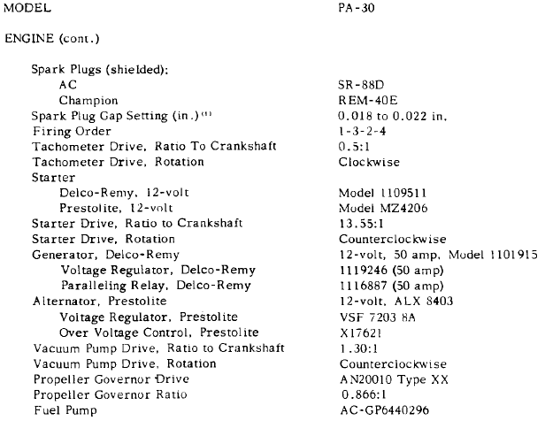

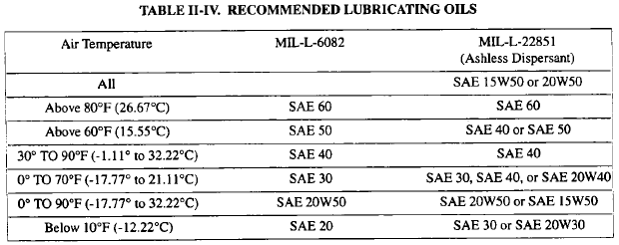

There is no restriction on maximum power output (p. 330, 2D20). Therefore, both takeoff power and MCP (Maximum Continuous Power) are 2700RPM/160bhp.

Engine fuel system

The fuel system of the 10-320-BIA engines consists of a Bendix RSA-5ADI type fuel injector and an AC fuel supply pump as an integral part of the fuel injector system.

Fuel injection is accomplished via Bendix self-purging servo regulator metering system.

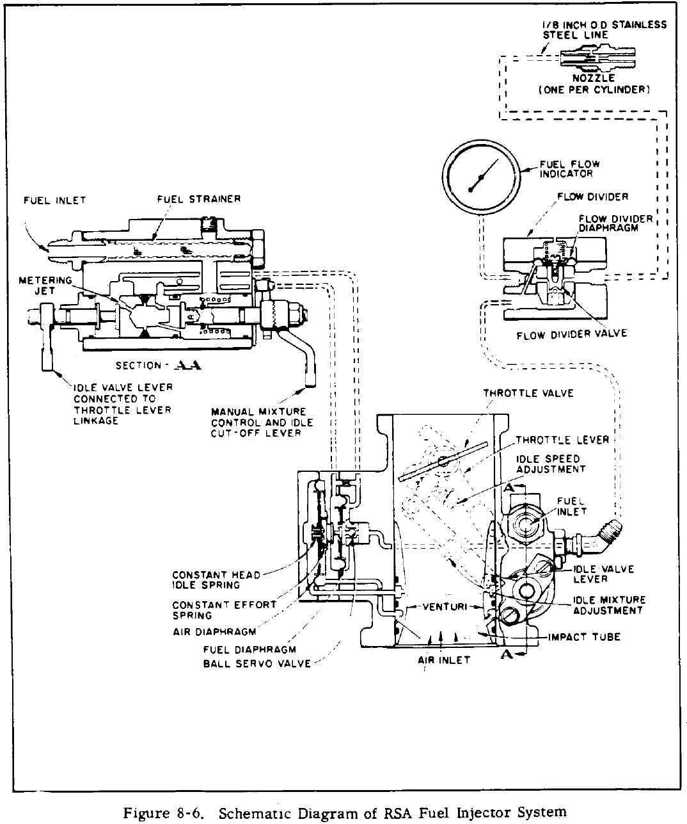

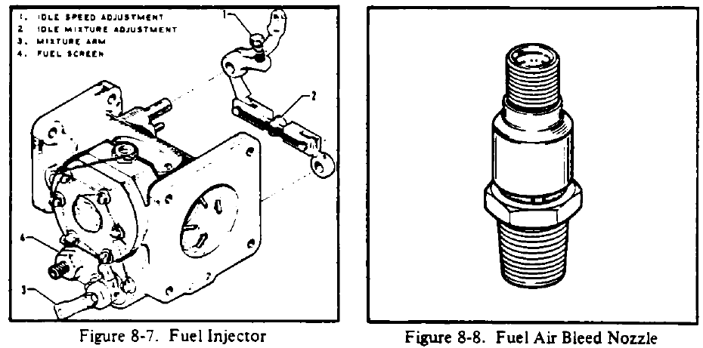
Ignition

Bendix Scintilla S4LN-21 series magnetos are installed on both engines. Each system consists of two single contact point magnetos with impulse couplings on the magneto drive shafts to obtain the retard spark necessary for starting.

Lubrication system

The lubrication system is of the wet sump type. The oil pump, which is located in the accessory housing, draws oil through a drilled passage leading from the oil suction screen located in the sump. The oil from the pump then enters a drilled passage in the accessory housing, which feeds the oil to a threaded connection on the rear face of the accessory housing, where a flexible line leads the oil to the external oil cooler. Pressure oil from the cooler returns to a second threaded connection on the accessory housing from which point a drilled passage conducts oil to the oil pressure filter. In the event that cold oil or an obstruction should restrict oil flow to the cooler, an oil cooler bypass-valve is provided to pass the oil directly from the oil pump to the oil pressure filter.

The oil pressure filter screen or element, located on the accessory housing, is provided as a means to filter from the oil any solid particles that may have passed through the suction screen in the sump. After being filtered through the pressure filter, the oil is fed through a drilled passage to the oil pressure relief valve, located in the upper right side of the crankcase forward of the accessory housing.

This relief valve regulates the engine oil pressure by allowing excessive oil to return to the sump, while the balance of the pressure oil is fed to the main oil gallery in the right half of the crankcase. Residual oil is returned by gravity to the sump where, after passing through a screen, it is again circulated through the engine.

Each engine contains a normal quantity of 6-7 US quarts, with a maximum of 8. A minimum safe quantity of 2 US quarts is specified. The oil grade is MIL-L-22851C.

Induction system

Induction air is normally drawn through a filter, but the induction system includes a spring loaded door which opens automatically if the filter becomes blocked, to allow air into the engine. Can also be operated manually with ALTERNATE AIR controls.

Propellers and governors

Propellers – Hartzell constant speed, full feathering, controllable pitch. 2-blades (72” diameter.) Alloy forged. Low pitch at 12 degrees, high pitch 78 degrees. Ground clearance 11 inches. Controlled by a governor (model F-6-3) mounted on the engine which supplies oil to the propeller at various pressures through the engine crankshaft. Oil pressure, therefore, moves the blades into low pitch (high RPM.) Propellers are Hartzell HC-E2YL-2BSF models. “The ‘S’ in the hub dash number indicates the presence of a backup spring which allows operation of the propeller in case of loss of air from the air cylinder.” Quoted from the Piper PA-30 Twin Comanche Service Manual, block 1-A17.

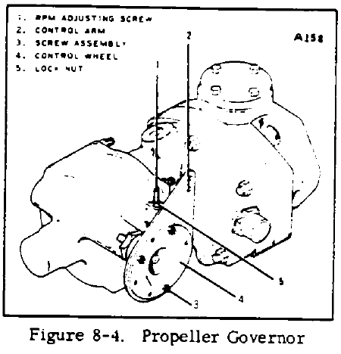
Feathering mechanism – dry nitrogen operated. Takes approximately 3 seconds. No accumulators are employed in the feathering process. The centrifugal twisting moment of the blades tends to move the blades into low pitch (high RPM) along with oil pressure from the propeller governor. Opposing these two forces is compressed air (or dry nitrogen) between the cylinder head and the piston, which tends to move the blades into high pitch (low RPM) in the absence of governor oil pressure. Thus, feathering is accomplished by compressed air/dry nitrogen. Note that with “S” model propellers a backup spring is used to allow propeller operation in the event of a loss of air/nitrogen pressure.

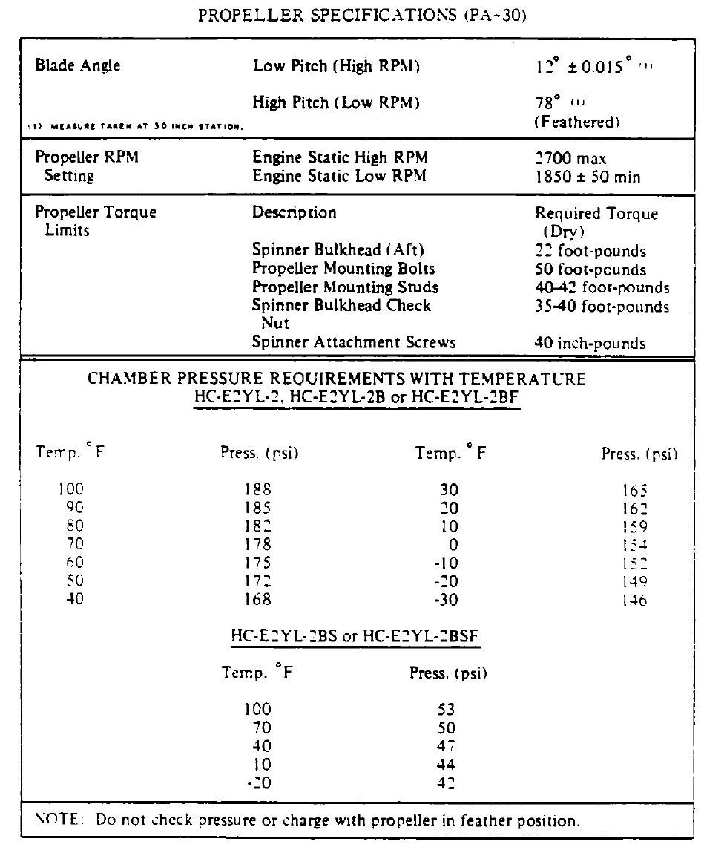
Landing gear

Maintenance Manual links:

Gear down-limit switches: p. 294, pictures at: p. 261 (nose), p. 281 (main)
Gear up-limit switch: p. 298, fig. 7-15 - only one, in hellhole, activated by torque arm assy.
Gear safety (squat) switch: p. 294 - left main gear
Gear warning switch: (microswitches) p. 302

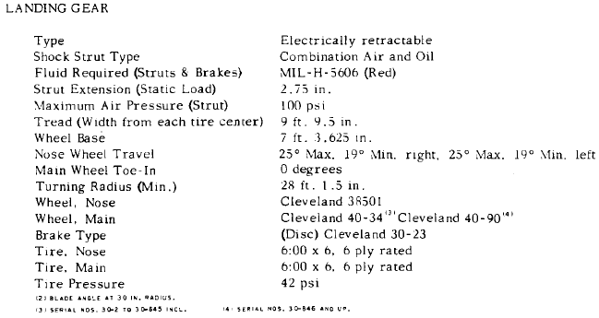

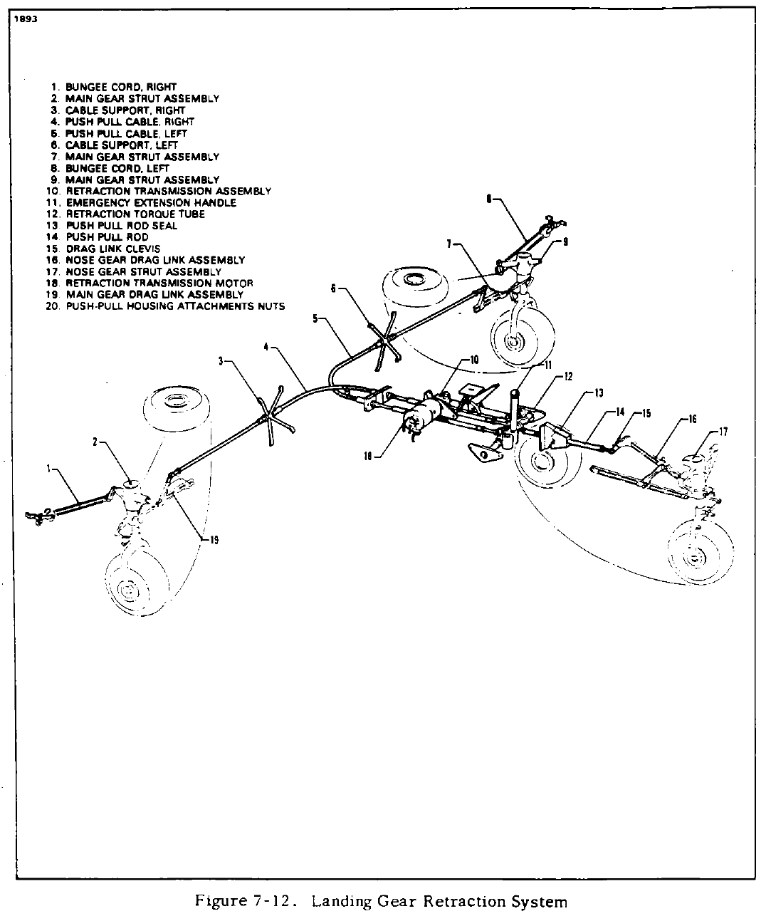

The PA-30 tricycle landing gear system is an air-oil oleo type unit that is electrically operated, fully retractable with the nose gear retracting aft into the nose section and the main gear retracting inboard into the wing. Gear doors operate by gear movement completely covering the nose gear and partially covering the main gear when retracted.

The retraction mechanism consists of an electric motor and transmission assembly, torque tube assembly, push-pull cables to each main gear and a push-pull tube to the nose gear. Limit switches are installed in the system to cut off the transmission motor when the gear is fully extended or retracted. These switches also operate gear indicator lights in the cabin.

There is one downlimit switch on each main gear and on the nose gear, and one uplimit switch located above the torque arm assembly in cabin hell-hole forward of the transmission jackscrew.

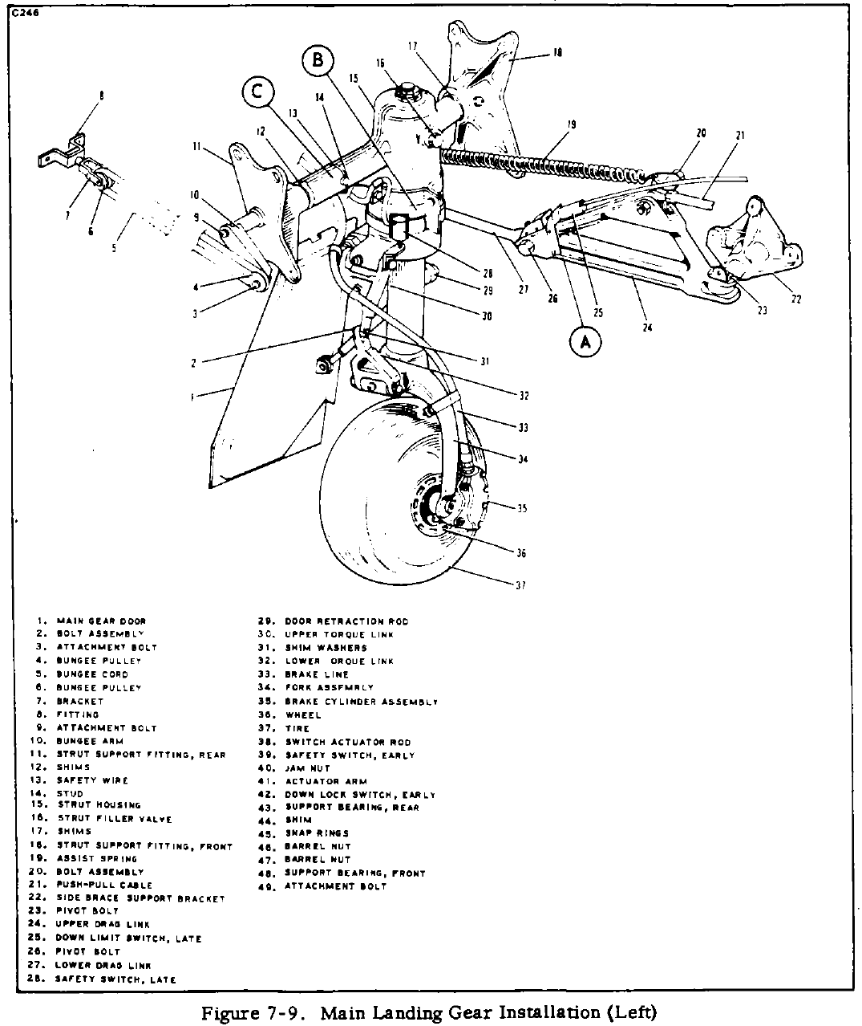

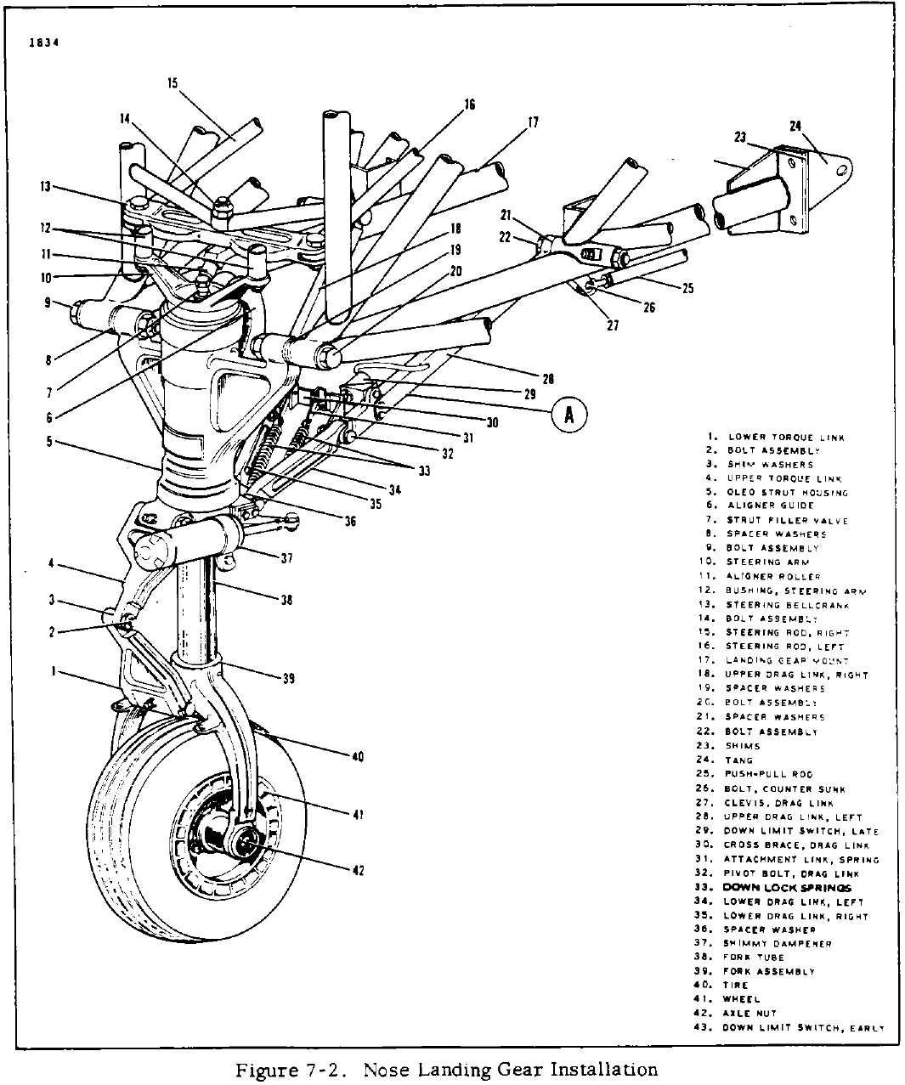

To prevent the gear from retracting while the airplane is on the ground, an anti-retraction safety switch located on the left main gear will not allow the gear to retract until weight off the gear has allowed the strut to extend to within three-quarters of an inch of full extension. When the manifold pressure is reduced below 10 to 12 inches and the landing gear is not down and locked, a warning horn will sound via microswitches located in the throttle quadrant. In the cockpit, located between the pilot seats, under the floor panel, is an extension handle used to manually extend the landing gear while in flight should it become necessary. Also, it may be used to extend and retract the gear on the ground while on jacks.

Tire pressure is 42 lbs. psi for all three tires, which are 6-ply 6.00x6.

Proper main gear strut inflation is 2 ¾” visible.

Brakes

The brakes are hydraulically actuated by individual master cylinders mounted on the left (optional on the right) set of rudder pedals. A reservoir located on the front side of the forward cabin bulkhead supplies hydraulic fluid to each master cylinder. From the cylinders the fluid is routed through lines and hoses to the brake assemblies on each main landing gear. The brakes are self-adjusting, single disc, single housing, double piston assemblies. MIL-H-5606 hydraulic fluid is used to fill the brake fluid reservoir.

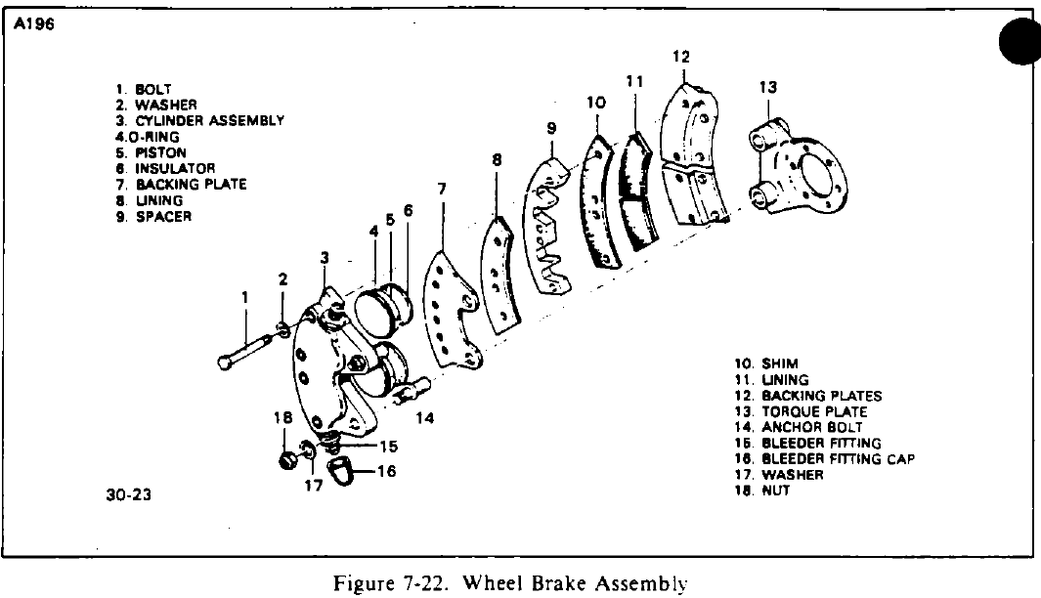

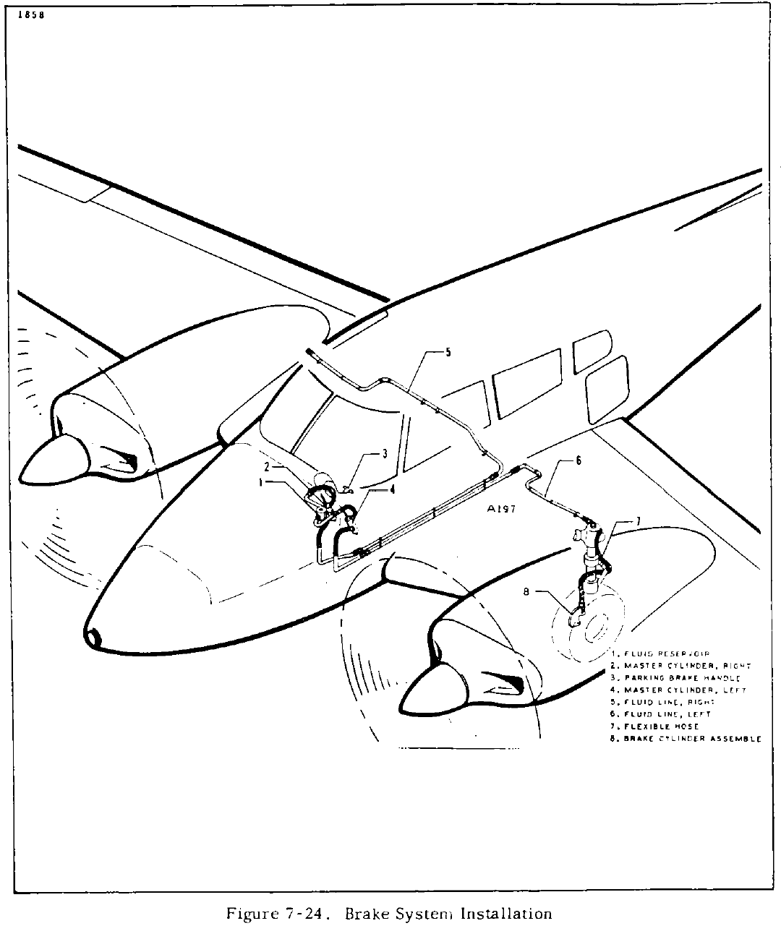

Fuel system (no tip tanks)

The fuel system is contained in two independent units that allow each engine to have its own fuel supply. The systems are connected only by a crossfeed that will allow fuel to be drawn from one set of fuel cells to the engine of the opposite side, in the event of an emergency. The fuel cells are of the bladder type installed in cavities in the wings, with each inboard (main) cell holding a capacity of 30 (27 usable) U.S. gallons and each outboard (auxiliary) cell holding a capacity of 15 (15 usable) U.S. gallons. (Total 90 gallons; 84 usable.)

For each engine, fuel is taken from each cell through a screen located in the cell outlet fitting and then on to a shut-off selector valve. From the selector valve, fuel is drawn through an electrically operated auxiliary fuel pump and on to an engine driven pump where it is pumped to the injector unit.

Drains and fuel screens are located in the fuel selector valves which are accessible through an access panel located just ahead of the main spar between the pilot seats or, for service purposes, in the bottom of the fuselage. The fuel valves are operated through controls located in a panel, just ahead of the main spar, between the pilot seats. Fuel gauges will indicate the quantity
of fuel in each cell from which the fuel is being selected.

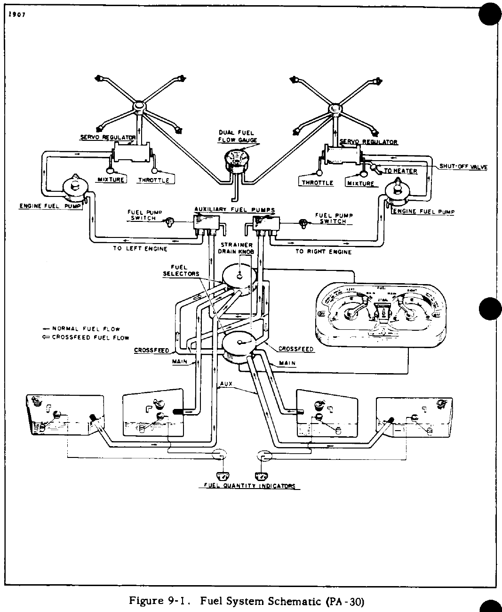

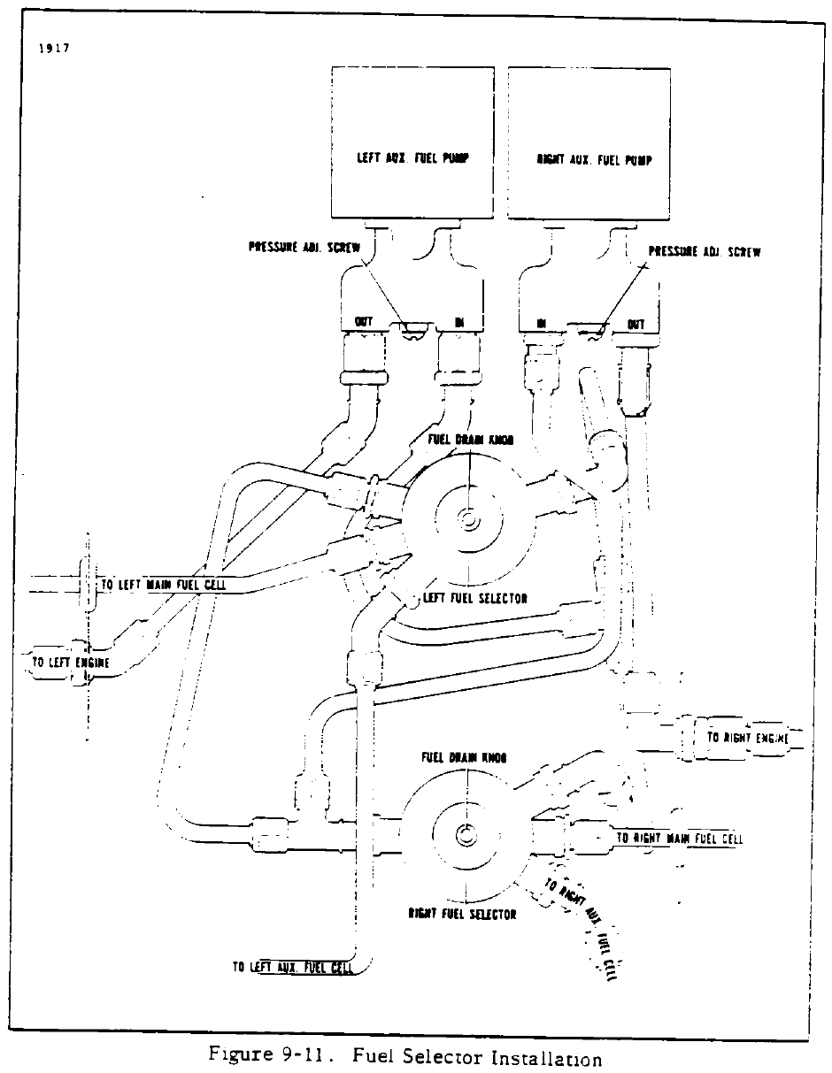

Vacuum system

The PA-30 gyro vacuum system is comprised of two rotary vane, positive displacement vacuum pumps, two regulating valves, two check valves, a manifold assembly, a central air filter, a suction gauge and necessary tubing and fittings. Due to suction from the vacuum pumps, air enters the central air filter, located on the forward cabin bulkhead, and passes over the instrument gyros causing them to turn. The air is then routed to the vacuum manifold where it enters two individual systems each having its own check valve, regulator and vacuum pump.

The check valve in each system at the vacuum manifold permits air to move in only one direction from the instrument toward the pump. If one system pump fails, its check valve will close, preventing the operative pump from drawing air through the inoperative system.

The system regulators located on the aft side of each fire wall allow air to enter the line to the pumps, preventing system vacuum from exceeding the operating limits. The vacuum pumps located on each engine accessory housing draw air through the system, causing the gyro instruments to operate. The suction gauge indicates the amount of vacuum at the attitude gyro as created by the engine driven vacuum pump. Also included in the gauge are a right and left indicator button which become visible when the corresponding pump is inoperative.

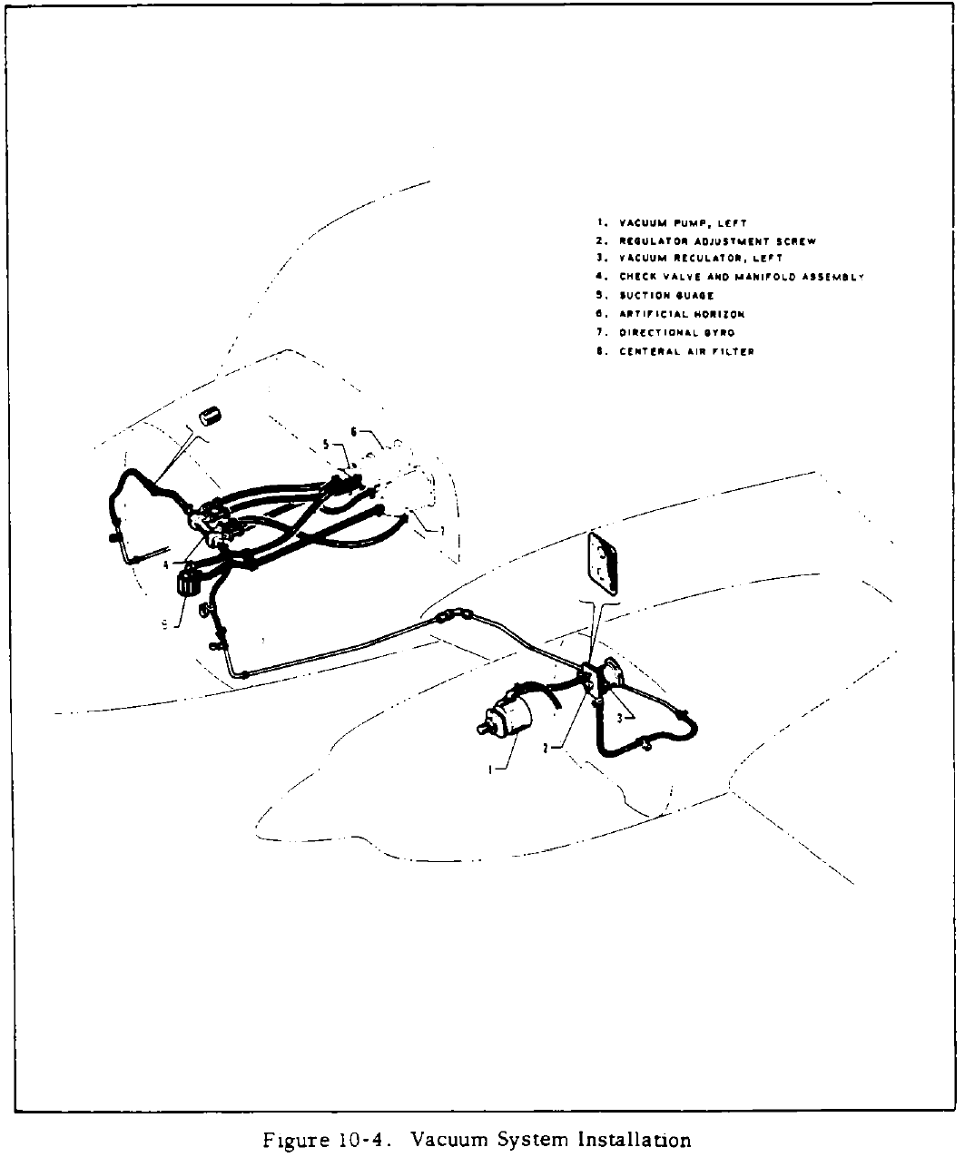

Electrical system

Electrical power is supplied by a 14-volt, direct current, single wire, negative ground electrical system. A 12-volt, 35 ampere-hour battery is incorporated in the system to furnish power for starting and as a reserve power source in case of generator or alternator failure. An external power receptacle can be provided as optional equipment to permit the use of an external power source for cold weather starting. A 50-ampere generator or 70-ampere alternator is supplied with the left engine as standard equipment. An additional generator or alternator of equal amperage may be supplied with the right engine as optional equipment. [N8259Y is equipped with two 50 amp generators.]

Electrical switches and rheostats are located at the left side of the cockpit under the instrument panel. The circuit breakers for the individual circuits are mounted on a panel under the floorboard directly aft of the nose wheel housing on early model airplanes and under the right side of the instrument panel on later model airplanes. The airplane is equipped with standard navigation lights, two landing lights located in the wing tips and a rotating beacon as standard equipment.

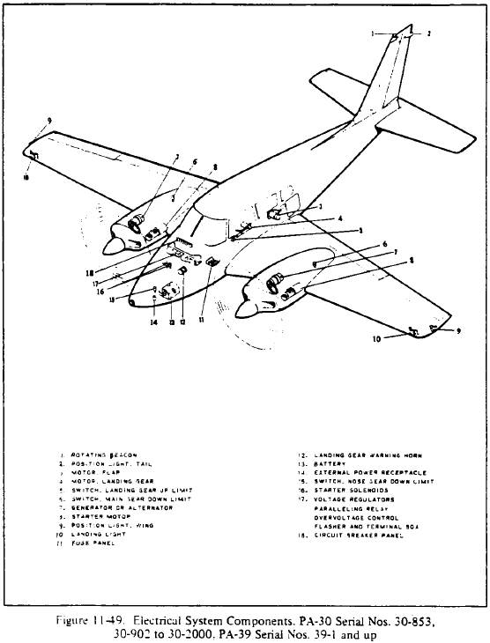

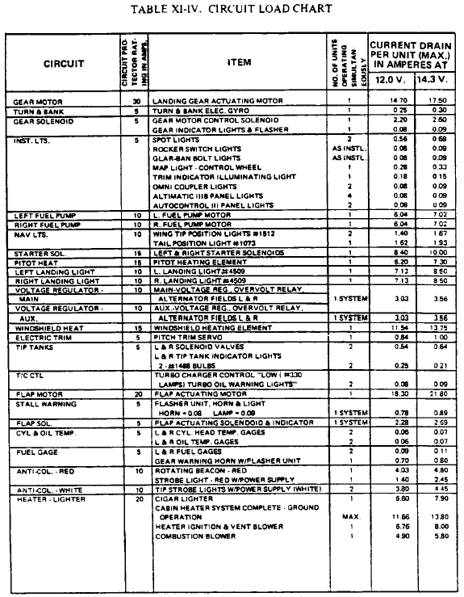

Generators

Two Delco-Remy 50-amp, 14 volt generators, one mounted below and to the left of each engine’s driveshaft. Full 50-amp output is derived at an approximate generator armature RPM of 3960.

The generator is of the two brush, shunt type and is controlled by a regulator operating on the principal of inserting resistance into the generator field circuit to cause a reduction of generator voltage and current output. With each generator is the regulator assembly, composed of a voltage regulator and current regulator, to prevent overloading of the battery and electrical circuits. Also with the regulator is a reverse current cutout to prevent the generator from being motorized by the battery when the generator output drops below the battery voltage. Where dual generators are used, a paralleling relay is used to connect the two generators. [Editorial: Modern electronic voltage regulators may negate the need for a separate paralleling relay. N8259Y features Zefftronics electronic voltage regulators.] The generator is located on the front lower right side of the engine and utilizes a belt drive from the engine crankshaft. The generator voltage regulator is located on the engine firewall. The best assurance of obtaining maximum service from the generator with minimum trouble is to follow a regular inspection and maintenance procedure.

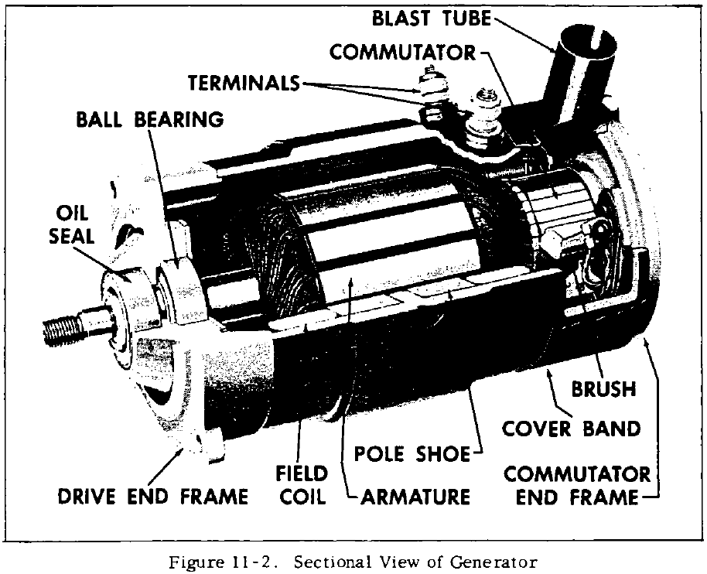

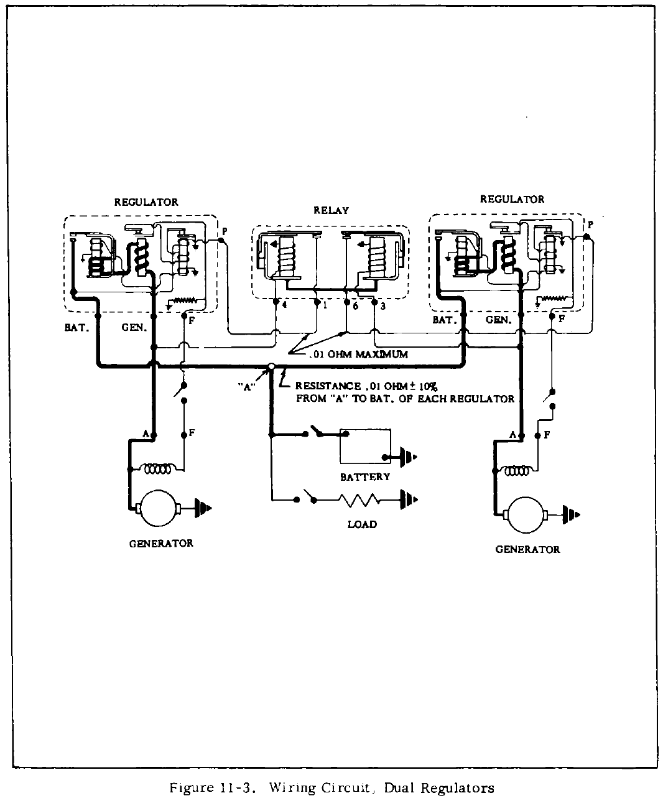

Heating and ventilation system

The flow of air for heating and defrosting the Twin Comanche is taken through an inlet located in the nose and regulated by controls located in the lower right side of the instrument panel. Heated air for the cabin and windshield defrosting is provided by a South Wind (Serial Nos. 30-1 to 30401 inclusive) or Janitrol (Serial Nos. 30402 and up) [N8259Y is equipped with a Janitrol heater.] heater installed in the right side of the nose section and is accessible by removing the nose access cowl. The heater uses gasoline from the fuel injector on the right engine. Therefore, anytime the right fuel selector is off the heater is inoperative. In case of right engine failure, the heater can be operated by leaving the fuel selector on and operating the auxiliary pump. The mixture control must be cosed. Before the heater is operated under these conditions, it must be determined that no fuel leaks are present between the tank and engine.

Ventilating air for the cabin interior is obtained from two individual sources. The two
ventilators located at each side of the instrument panel obtain air from the inlet in the
fuselage nose. Air for the two overhead vent outlets is obtained from a scoop mounted on
the dorsal fin. Each individual vent is adjustable for the desired airflow. Located in the aft
section of the cabin is an exhaust vent to improve the circulation of air in the cabin interior.

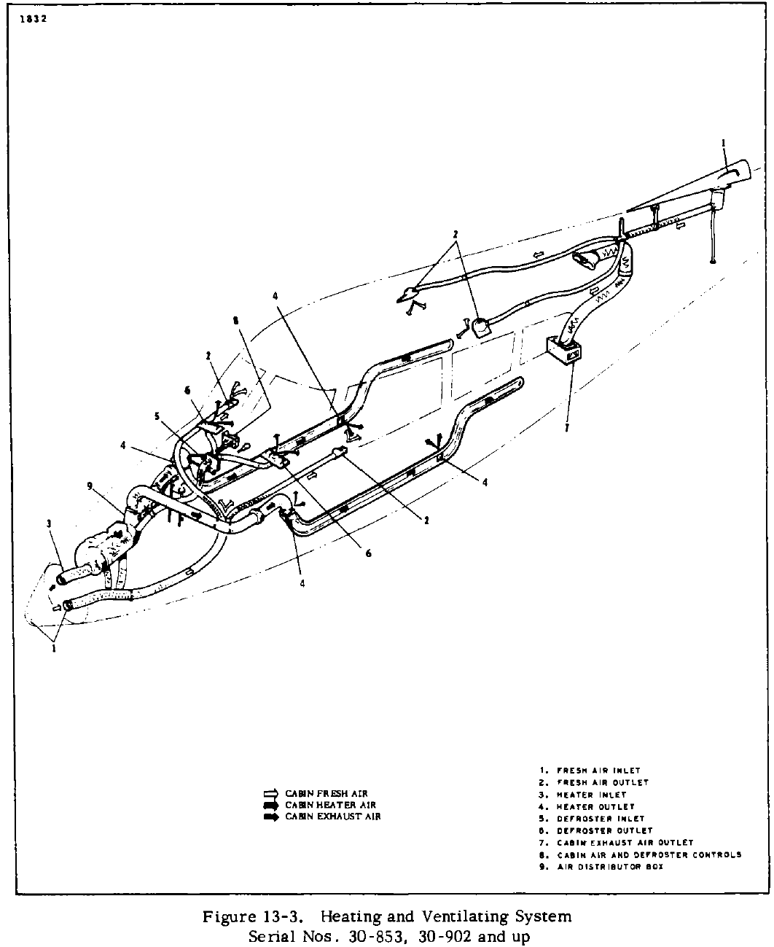

Heater safety limit switch

Located in the South Wind and Janitrol heaters is a heat limit switch, which acts as a safety device to render the heater system inoperative if a malfunction should occur causing excessively high temperatures. This control is located in the downstream end of the vent jacket, with the reset button on the heater shroud. It is reached only through the nose section to insure that the malfunction causing the overheat condition is corrected prior to future heater operation.

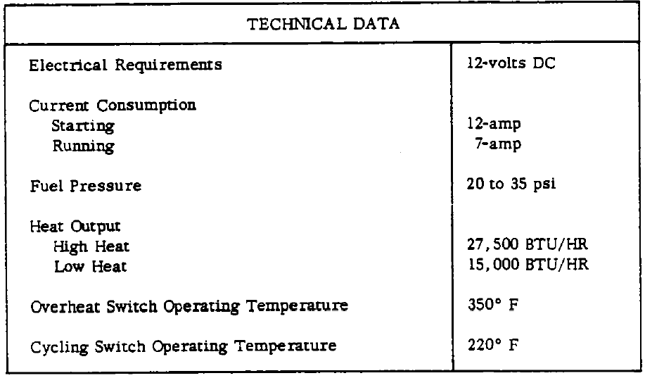

Autopilot

PA-30B N8259Y is equipped with an Altimatic IIIB two-axis autopilot with altitude hold and the Piper AutoFlite backup autopilot system. Reference the Century Altimatic IIIB operating guide for further information.

